9. REACTJS-HOL

1. Created a new react app named cricketapp.

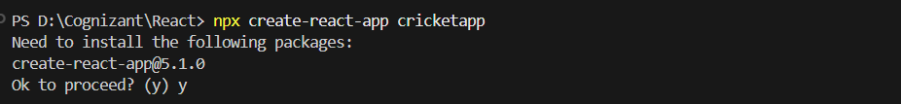

2. Created two components ListofPlayers.jsx and IndianPlayers.jsx

|  |  |
| --- | --- |
|  |  |

3. Implemented App.js as mentioned

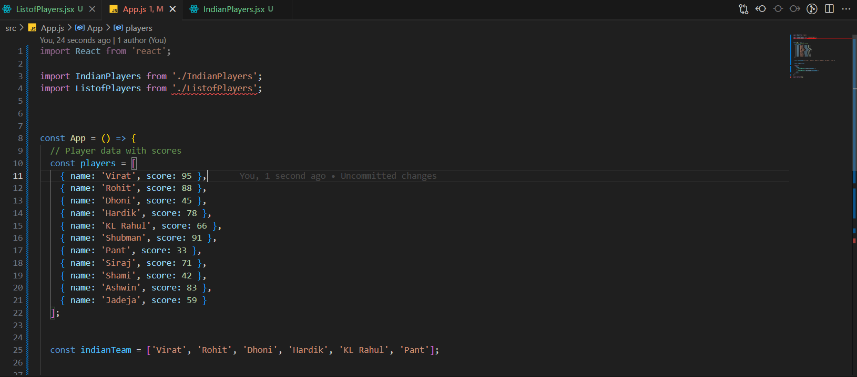

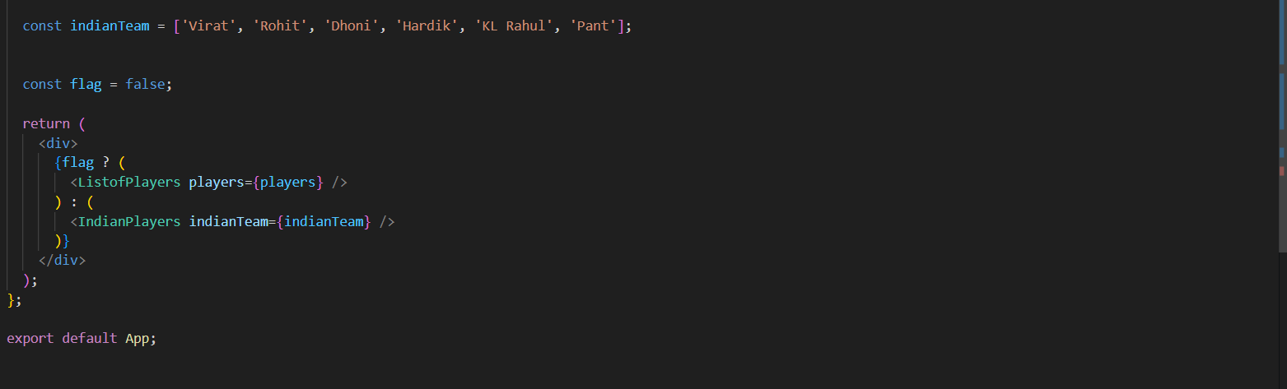

Output,

When flag = true,

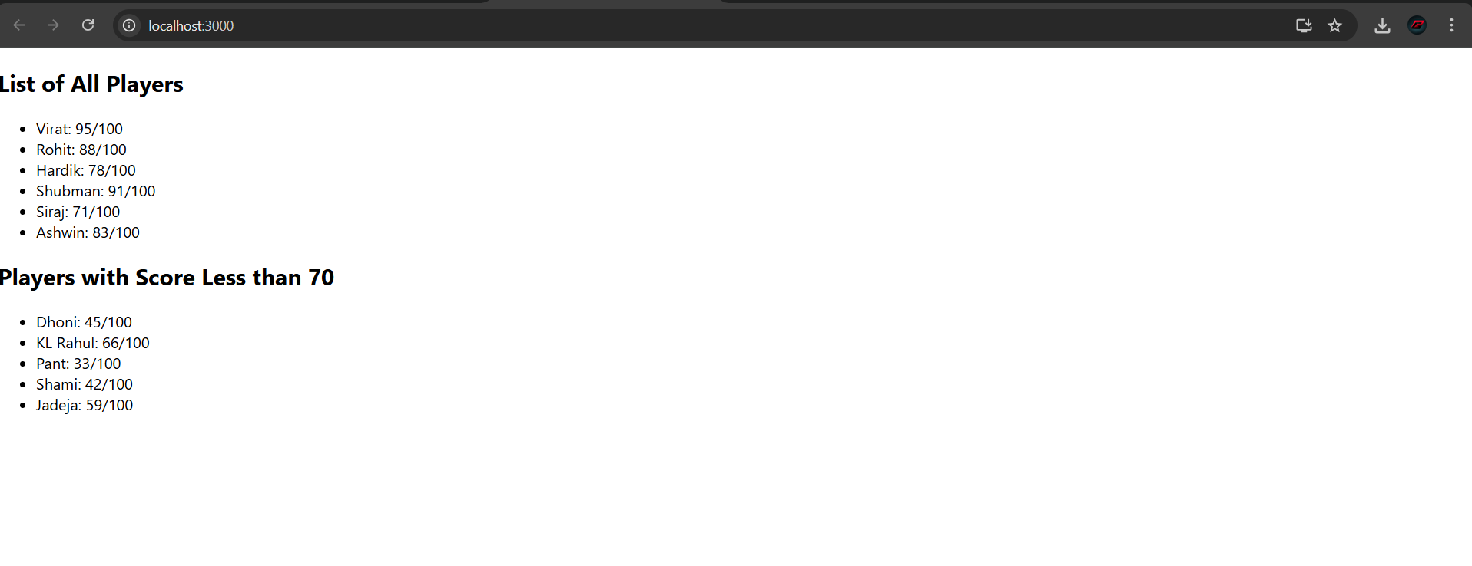

When flag = false



10. REACTJS - HOL

1. Created the react application

2. Created an attribute to display the heading

3. Attribute to display image

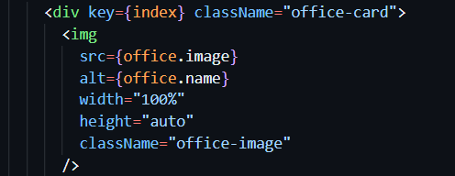

4. Office object to store details

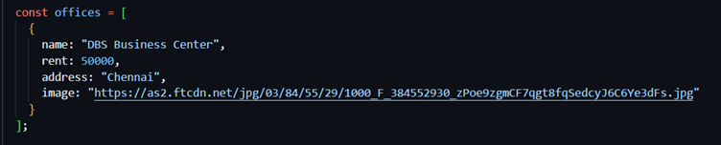

5. Used map function instead of looping through office objects

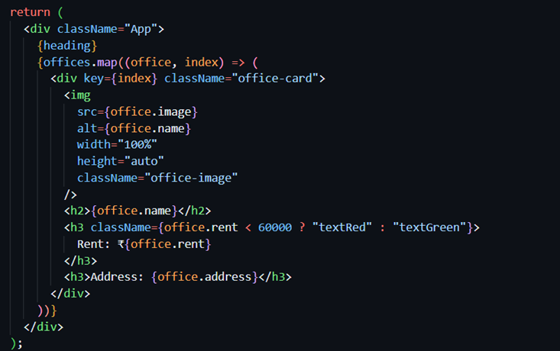

6. Applied css

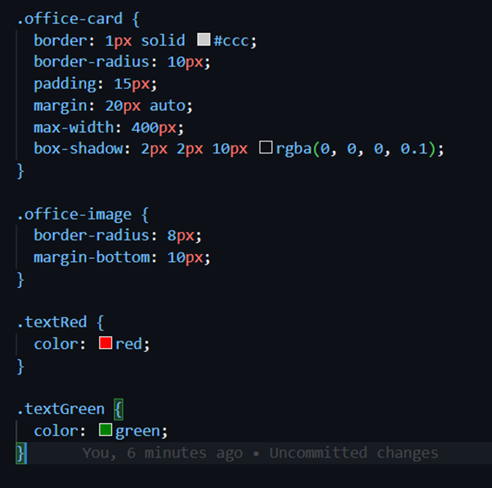

7. Final Output



11. REACTJS-HOL

1. Created a new react app

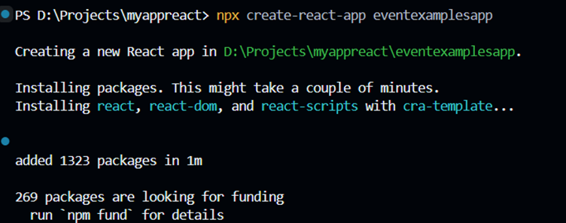

1. Create “Increment” button to increase the value of the counter and “Decrement” button to decrease the value of the counter. The “Increase” button should invoke multiple methods.

a. To increment the value

b. Say Hello followed by a static message.

2. Create a button “Say Welcome” which invokes the function which takes “welcome” as an argument.

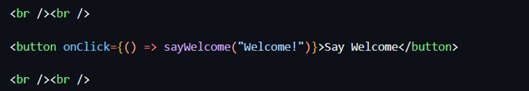

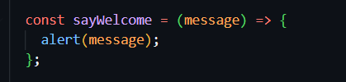

3. Create a button which invokes synthetic event “OnPress” which display “I was clicked”

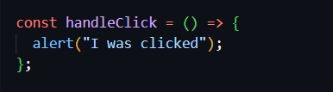

4. Create a “CurrencyConvertor” component which will convert the Indian Rupees to Euro when the Convert button is clicked.

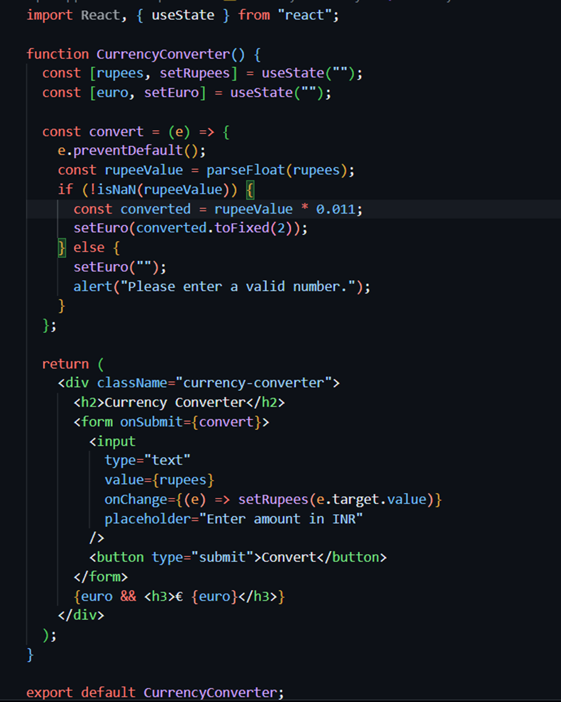

5. Handle the Click event of the button to invoke the handleSubmit event and handle the conversion of the euro to rupees.



output

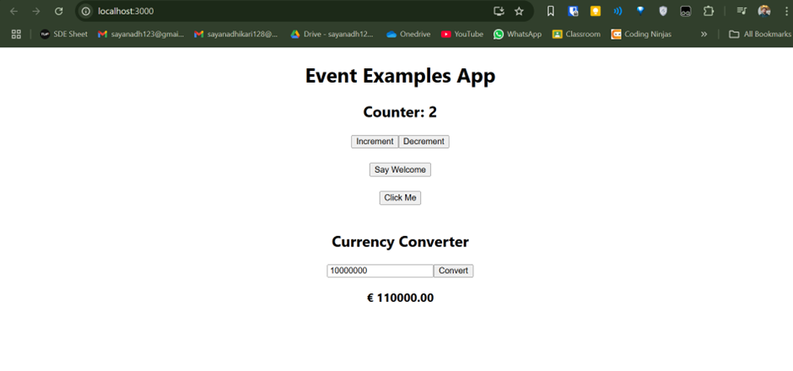

12. REACTJS-HOL

1. Create a React Application named “ticketbookingapp” where the guest user can browse the page where the flight details are displayed whereas the logged in user only can book tickets.

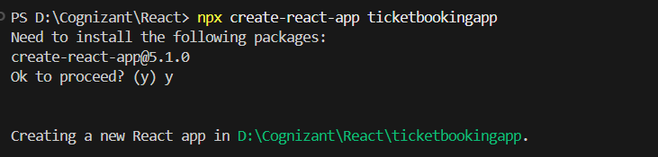

2. The Login and Logout buttons should accordingly display different pages. Once the user is logged in the User page should be displayed. When the user clicks on Logout, the Guest page should be displayed.

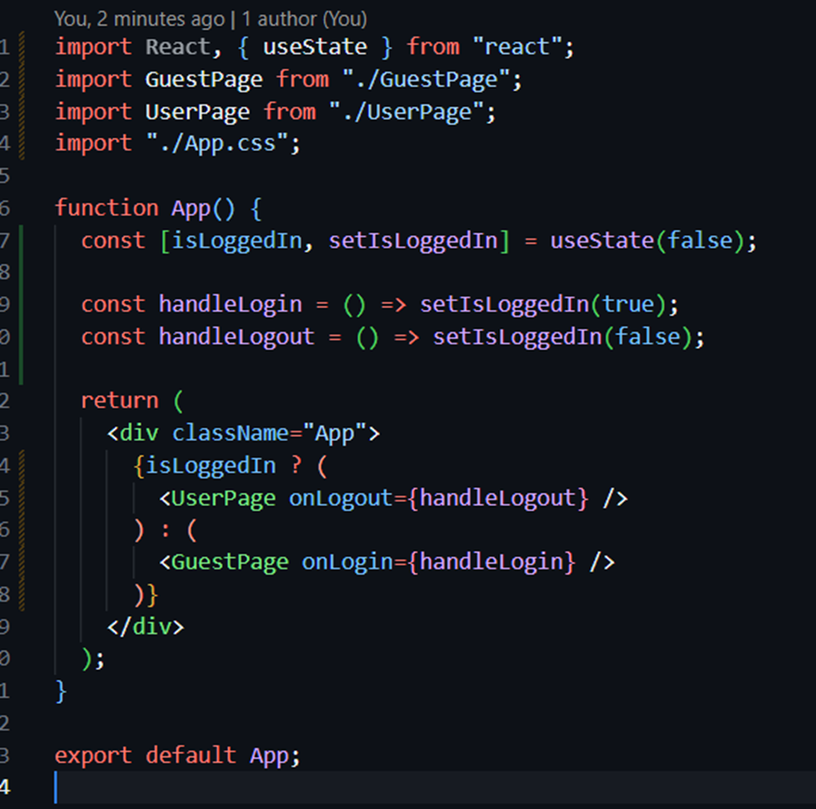

Made two components, one to render when user is logged in one where user is not

GuestPage.js

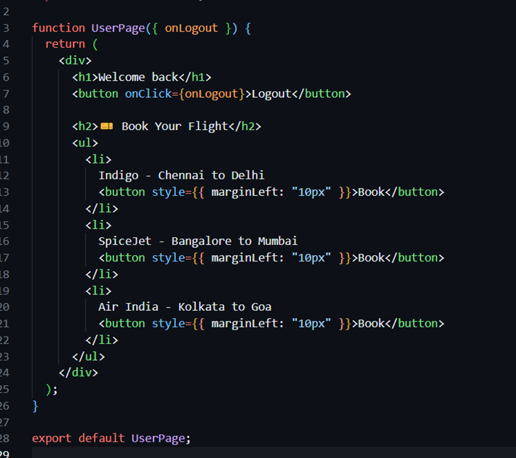

LoginPage.js

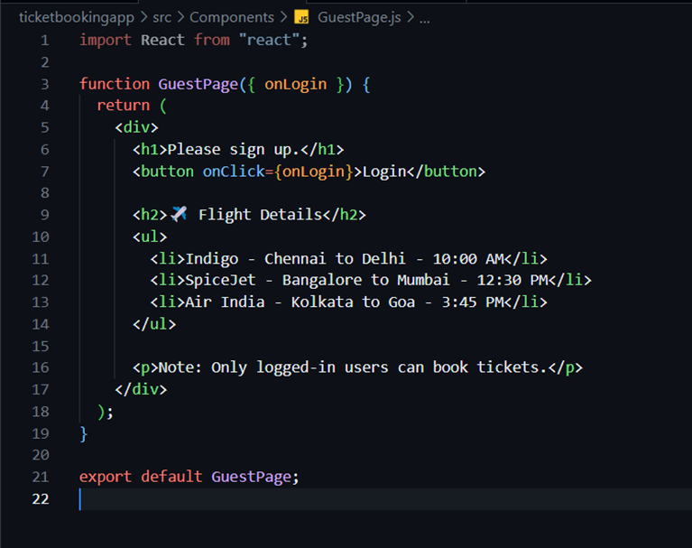

Output,

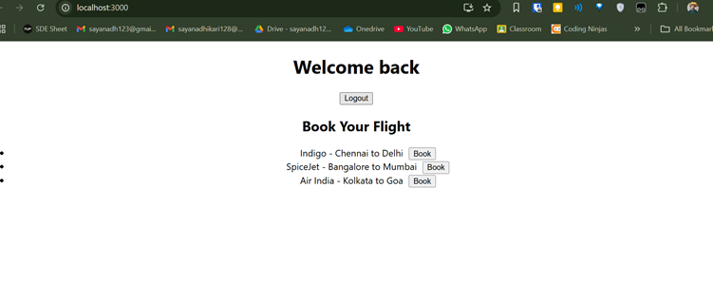

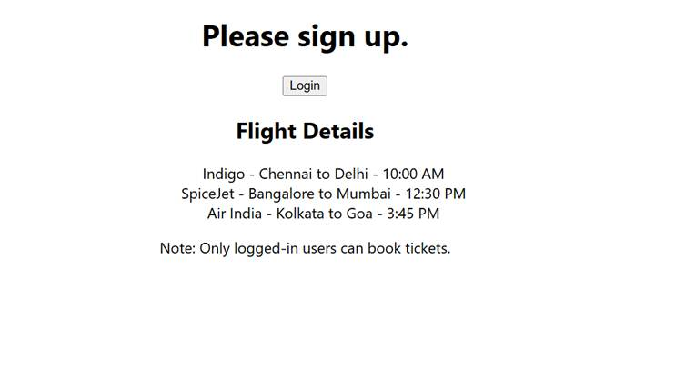

13. REACTJS - HOL

1. Created a new react app

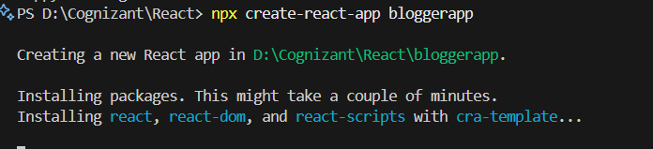

Create a React App named “bloggerapp” in with 3 components.

1. Book Details

2. Blog Details

3. Course Details

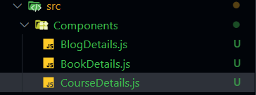

1. BlogDetails Component

2. BookDetails.js

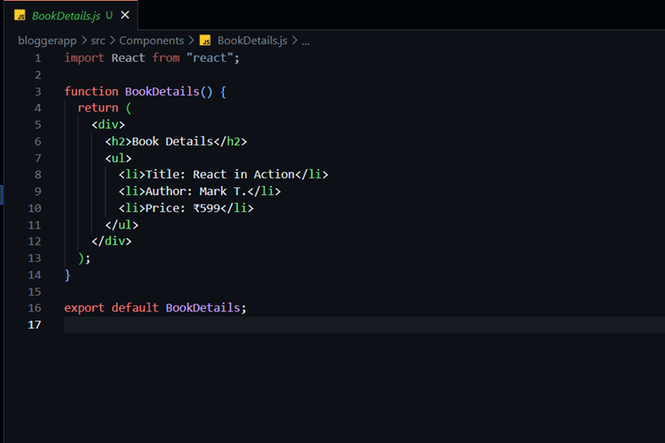

3. CourseDetails.js

Output,



